Why companies should care about e-care

McKinsey Quarterly article August 2014

Synopsis

E-care: self-service for customers online

This dramatically reduces your staffing need for phone and email contact centers. This also drastically reduces your need for physical store space and in person interactions. The cost savings enable significant upfront investment for large long term savings.

Measuring performance: Companies too often evaluate their customer service performance one mode at a time. To truly improve or evaluate customer service, companies should evaluate communication holistically across all modes because many customers bounce between modes on the same issue. This process also identifies inefficiencies from e-care. A good guiding question here is “How many service requests are initiated in one channel and completed in another, thus effectively increasing cost per request?”

Thoughts: The article professes 20 to 30% reductions in your customer service related costs and claims that every industry with customer service functions should explore this opportunity. I would argue that this is too simple of an analysis because there is still significant “stickiness” in customer service preferences. Older generations staunchly rely on phone interactions and even snail mail over digital alternatives. This is more apparent in established industries such as manufacturing and other commodity markets. Younger generations generally do prefer self-service but this desire is not ubiquitous across all generations and must be kept in mind when considering e-care initiatives. Additionally, when in doubt, nearly everyone turns to the phone to talk to a live person. Therefore, you can’t abandon certain modes no matter how hard you push customers online (another tactic the article suggests later).

Digital customer service is now a strategic imperative, but its adoption is hampered by weaknesses in delivery strategies and incomplete measurement of its effectiveness.
August 2014 | byRaffaella Bianchi, Davide Schiavotto, Daniel Svoboda
A European telecommunications company wanted to lower the cost of its customer service operations but worried about the potential loss of revenue from the cross-selling that its traditional call centers did so well. In investigating its options, the company learned that 70 percent of existing customer-service contacts could be delivered through digital solutions that had proved effective in other industries. By migrating part of its customer-service operations to similar digital-care programs with a smart strategic approach, the company lowered the unit’s costs by as much as 30 percent, with no loss of revenue.
Already well established in banking and financial services, digital customer care—so-called e-care—is now making inroads in other industries. E-care involves the delivery of customer service via web-based user accounts, social networks, mobile phone, and the Internet rather than call centers or facilities open to the public such as retail stores or service counters. Such digital services are increasingly demanded by customers, who are already using digital platforms to research and review products, as well as broadcast their service frustrations. And it makes sense from a financial perspective, too: e-care has the potential to significantly lower the cost of customer service operations while increasing customer satisfaction.
Of course, it’s not simply a matter of adding digital options to traditional customer-service channels. In our experience, e-care must be approached as a one- to two-year multistage transformation, undertaken with the same degree of planning and rigor as a major product launch or other strategic initiative and backed by heavy initial C-suite support. In addition, careful thought must be given to the degree of digitization desired: digital care can be fully self-serve or involve a mix of live customer-service agents; not all options need to be available on every digital platform, and e-care should not be implemented as aggressively where there is significant potential for upselling. Yet we believe that the rewards of adopting e-care are worth the effort, and virtually every consumer-facing industry requiring extensive customer-relationship management—from cable operators and consumer electronics to healthcare and utilities—can benefit.

Getting from here to e-care
Digital customer service has become a significant factor in both purchase and service transactions: roughly 70 percent of telecommunications purchase journeys occur in part or in whole online, as do 90 percent of service journeys.¹Digital customer service also provides superior customer satisfaction: our research shows that 76 percent of telecommunications customers are satisfied with a customer service journey that is fully digital, compared with 57 percent satisfaction for interactions through traditional channels (exhibit). When you consider that migration to e-care can, in our experience, reduce call volumes and operating expenses by 25 to 30 percent, its benefits seem obvious.
Yet these statistics mask the fact that few purchase journeys or service interactions are handled entirely digitally: according to our survey, while 41 percent of service interactions with telecommunications companies begin on an e-care platform, just 15 percent are digital from start to finish. Additionally, the rigorous fact-based management that accompanies traditional customer-service delivery is often absent from e-care. In our survey, we found that less than 40 percent of companies track key performance indicators related to customer experience for mobile channels and only 50 to 60 percent do for online interactions. In contrast, a typical call center tracks more than five metrics to manage customer experience.

Exhibit
The more digital the journey, the higher the satisfaction.
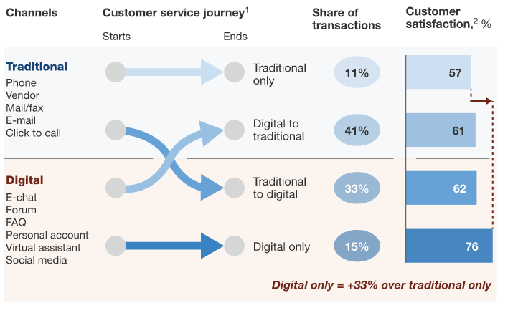
The problem is that companies from customer-facing industries that deploy multiple customer service channels too often assess the effectiveness of e-care by measuring individual channels, when customers today often move from one channel to another as they try to resolve service issues. They may start looking for an answer on the company’s website before switching to its mobile app, posting a comment or question via social media, and then finally turning to the call center if they have been unable to find an answer elsewhere. That’s why it’s critical to measure the multichannel effectiveness of e-care—something many companies still are not capable of doing. For instance, how many customer-service calls no longer need to go to a call center because the customer’s problems have been resolved through digital options? How many customers are seeking service through digital channels only, instead of using a mix of call centers and digital channels? How many service requests are initiated in one channel and completed in another, thus effectively increasing cost per request? Customer-service managers should be asking for this kind of data and examining it monthly, if not more often, as they judge the effectiveness of e-care efforts. The paradox is that while 70 percent of customer-care contacts at telecommunications companies are digital, they have produced only a small share of cost savings.
We find that most successful e-care rollouts have a single, cross-functional team responsible for the effort, and that team reports directly to the C-suite. In one telecommunications company, the team reported directly to the CEO. Proximity to the top of the organization allows digital-care team to cooperate more smoothly with the rest of the company and, just as important, makes it clear to the rest of the company that digital care matters. First-rate e-care companies treat digital customer service as a long-term, strategic transformation, not a bolted-on capability. They maintain momentum and focus throughout the process, vigilantly keeping an eye on the customer experience and potential business risks such as customer churn. Based on our research and work in e-care transformation, we have identified six stages of a successful digital-care strategy:
- Figure out what’s broken. Take a complete inventory of your current e-care program, developing a fact base from the perspective of your consumers—what digital-service touchpoints and functionalities you offer and how you offer them. Often, you’ll find that problems are straightforward. For example, one Western European telecommunications company realized not only that it had failed to build some touchpoints and functionalities important for customers but also that the customer experience on its web channel was so poor it was actually driving traffic to the call center rather than alleviating it. An audit of customer-service requests also can clarify priorities. One company found while there were some 2,000 different reasons for customers to contact a call center, only 60 problems—just 3 percent of the total—accounted for 65 percent of call volume and 55 percent of costs. In addition, just 15 of these 60 problems had a direct online solution. This meant that, all things being equal, designing online solutions for the remaining 45 priority issues had the potential to cut the company’s call-center volume and costs by as much as half.
- Build out an e-care contact strategy map. It’s easier to plan a journey when you know where you want to go. By developing a granular map that shows which customer requests can be addressed at which touchpoints, a company can see where digital functionality should be developed. In this step, it is also crucial to identify which types of service requests should not be pushed to digital too aggressively, or at all, to avoid jeopardizing cross-selling opportunities. To prevent revenue losses, some digital touchpoints should also enable service-to-sales functionality. For example, one European telecommunications operator successfully implemented video chat to cross-sell service to customers using digital service.
- Build a dashboard. Being able to measure customers’ experience by channel and their migration between channels is the only way to ensure control and continuous improvement. For one player, tracking cross-channel activity helped management understand the nature of customer-service requests and how well or poorly the company resolved them. For instance, it learned that 37 percent of customers who initiated a fault ticket online subsequently contacted the call center within a day, thus leaving a lot of savings potential on the table and making service resolution more complicated for the customer.
- Set goals. The first target numbers that should be set are the level of self-service use and call center operational savings. Here, too, targets should be granular, defined at the level of individual reasons for contact. For example, a telecommunications company set a migration target for certain activities, such as repairs and administrative information. If its e-care migration continues on track, call volume will fall by 20 percent in the next two years.
- Deploy a mix of “pull” and “push” strategies to make customers go online. To speed up adoption of e-care services, customers must be “pulled” online with the promise that it will be easier to accomplish particular tasks. For instance, one company educated customers at the point of sale when they bought a new product and publicized its digital services through call-center recordings and agents. Another company communicated relentlessly the convenience of digital touchpoints through “send to a friend” social campaigns that relied on satisfied digital-care users. To complement pull efforts, companies can “push” customers not to do things the same old ways. A push migration plan could entail allowing activation, configuration, and repair for new service only through digital channels.
- Synchronize the change effort. Appoint a cross-company committee to lead all project management of digital customer-service activities, align performance management, improve cross-functional communication and alignment on digital projects, and set up an advanced data model to track e-care key performance indicators across the organization.
Taking a systematic approach to e-care can not only reduce costs and improve service but also bring a company closer to its customers, who now actively use digital platforms to research and review products, purchase services, and communicate problems. Digital customer service increases customer satisfaction, but it cannot simply be bolted on to traditional customer-service channels. The transition to e-care is a one- to two-year multistage project that must have substantial C-suite support at the outset. But we believe that adopting e-care is worth the effort and that virtually every consumer-facing industry that has high customer-relationship needs can benefit from it.

